A570-US-UT-Muddy River-Clovis Core-10,000 BCE

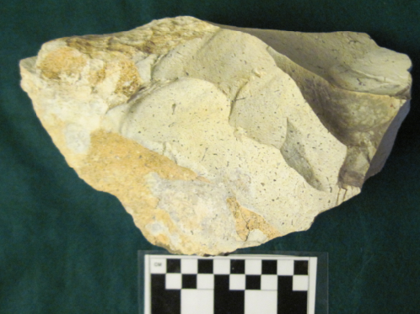

**Case No.: 11**

**Accession No. A570**

**Formal Label:** US-UT-Muddy River-Clovis Core-10,000 BCE

**Display Description:**

**This core represents the broad flaking technology that was implemented by Clovis people and also represents a type of flint they sought in making their Clovis points.**

**LC Classification:**

**Date or Time Horizon: 10,000**

**Geographical Area: Muddy River, Utah**

**Map:**

**GPS coordinates:**

**Cultural Affiliation:**

**Media:**

**Dimensions:**

**Weight:**

**Condition: original**

**Provenance: Muddy River, Utah**

**Discussion:**

**References:**